11. Finding further content

Two main resources
You are very fortunate that AFDO has already developed a great deal of information in relation to the NDIS. But what happens if you need more information:
There are two main options available to you that we will go through in a bit of detail with now. Once you get back home, we woould encourage you to take some time to have a look around yourself, so that you are familiar with the sites, so that if someone does ask a question, you know where to find the answer.

The NDIS website is www.ndis.gov.au
The NDIS website is the place where all the official information on the NDIS can be found. It is useful way of getting basic information, as well as well as finding answers that may come up.
There are two main ways to find the information you need;
- Use the headings to navigate around, or
- Use the search function.

navigate using headings
The NDIS website is divided into sections according to what type of person is looking for onformation. It has a range of headings for:
- People with disability, who are not yet in the scheme
- Families and carers
- Participants – people who are already in the NDIS
- Providers – the people who work for organisations that provide services
- Community and
- News
It is likely that the heading you will use the most is the ‘Participants’ tab, but it is good to be aware of all of them.

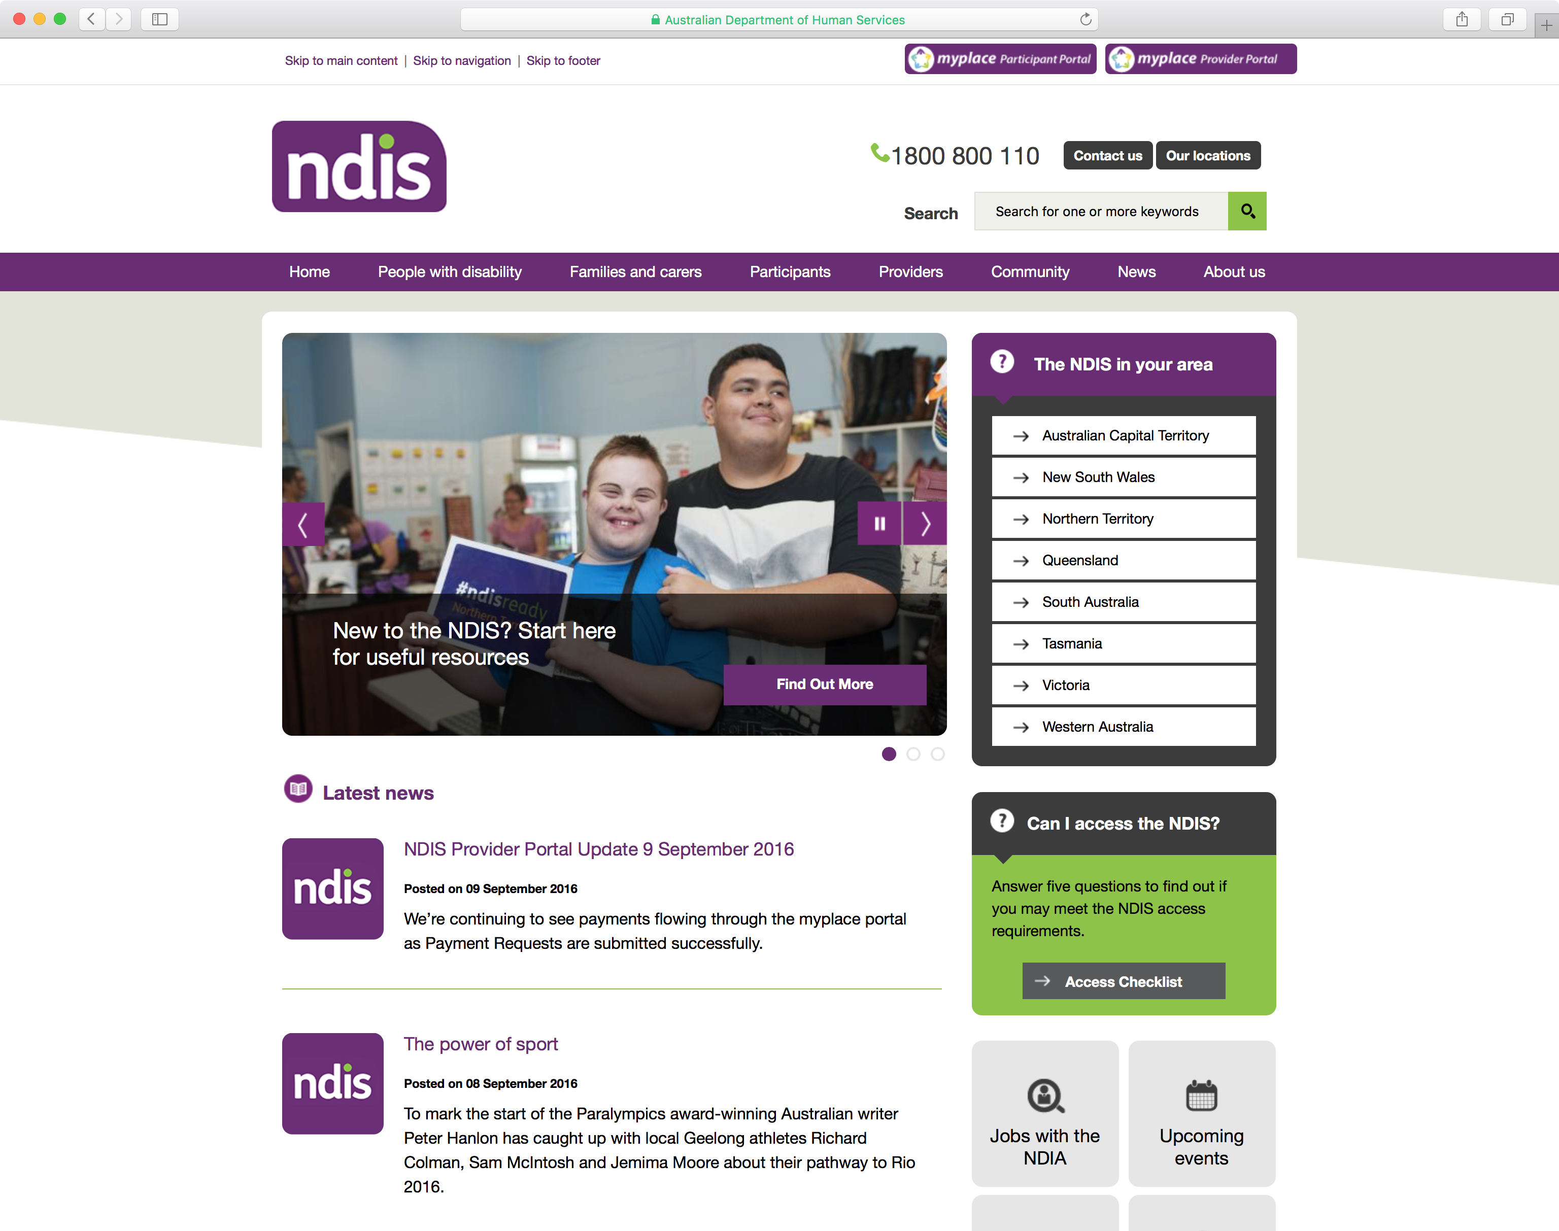

activity
Let’s take a moment now to look for some of the more common pieces of information from the NDIS website:
- Information on the rollout schedules for each state and territory
- Where is ‘The My NDIS Pathway’ booklet?
- Where is ‘What is the NDIS’ booklet?
- How do people find out how to access the NDIS?
- How can people find a Service Provider

navigate using the search function
The NDIS website is quite complicated and it can be hard to find the information you want just by using the headings. The other way to to find the information you need is to use the search function.
Search functions work best when you know some specific keywords that describe the information you want to find out. When using the search on the NDIS website, don’t write sentences like “Can I get support if I live in Sydney?”. Instead, use a couple of words, like “New South Wales NDIS”.
When you do find information on the NDIS website, especially using the search function, it’s a good idea to check the date the information was written. The NDIS is changing all the time, which is a good thing because it means they are growing and improving the scheme. However this means you need to make sure the information you find is up-to-date.
The website includes information in a range of formats, which includes fact sheets and publications as well as information about what help people are able to get.

Activity
You have made a presentation to a community group, people are asking for examples of the type of supports that will be available.
You have referred them to the NDIS website. In small groups, answer the following questions.
Questions
How would you suggest people would find the information they need?
What options would be available to them?
What navigation tools would you tell them to use? The search function or the menus?
What should a person do if they had really specific question? How should they try to find this information?

How to use the Disability Loop website
Disability Loop can be accessed by going to www.disabilityloop.org.au.
Disability Loop is a collection of resources run by AFDO that aims to give people with disability and families information about the NDIS that is up-to-date, easy to find and easy to use. Disability Loop always uses plain language to help everyone make sense of it all. Disability Loop includes an accessible website, eNews, online resources that explain the NDIS and NDIS news, social media channels as well as workshops and training.
There are many options for finding information on the Disability Loop website. Just like the NDIS website, there are a number of heading on the HomPage that help you get around the site. These are:
- Home
- News
- Resources
- Events
- Let’s Yarn
- NDIS Champions
- Contact

disability loop news
On the Disability Loop homepage is an invitation to ‘join the loop’. This is where people can sign up to receive the Disability Loop eNews. The eNews has news and information in about the NDIS that is accessible and written plainly. We receive excellent feedback on the way we explain many of the issues surrounding the NDIS.
One example is the very popular news article ‘A surge or a tsunami?’ The number of NDIS Participants during the trial compared to the full roll out.

disability loop resources
The resources section can be accessed by clicking on ‘Resources’ located in the menu bar at the top of the website. This section is multiple pages long and includes links to external resources, including tools and ideas that help people better understand the NDIS.
As there are lots of resources available, some categories are split up based on the type of content, such as ‘video’, and ’Easy English’. Others are based on diagnosis, such as ‘blind or low vision’, ‘Autism’, ‘physical disability’, etc. Categories also include locations, such as ‘national’, or any of the Australian states & territories. Also, the category might reflect the topic of the resource - such as ‘aids and equipment’, ‘peer support, ‘self-managing your funding’, and more.
Additionally, a search bar is available throughout the entire Disability Loop website, meaning you can search the entire site for specific information using keywords.
However, Disability Loop does not feature every NDIS resource out there. The NDIS website is the place to go to find formal documents, often available in a variety of accessible formats. The NDIS website can be difficult to navigate because there is so much information to look through. Using the search function is often easier than trying to use the navigation, particularly if you already know what you are looking for.
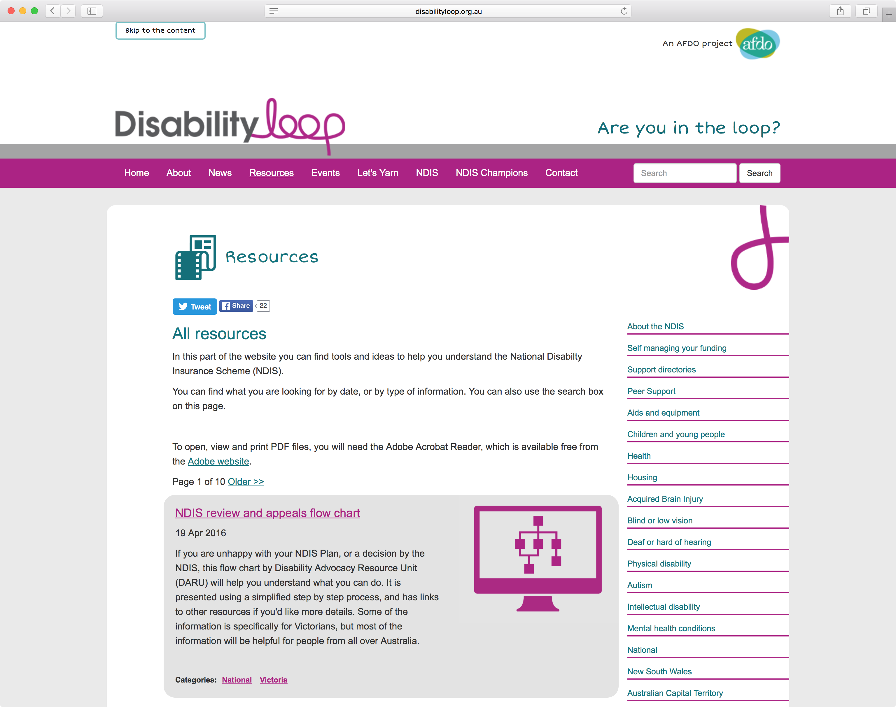

disability loop NDIS champions
You simply place your cursor over the heading marked NDIS Champions and it will take you to the NDIS Champions page.
As you can see, this gives an overview of the program you are now involved in, although at this stage it is still about what it is and how to apply.
AFDO will be updating this in the next couple of weeks to include soft copies of all the resources we have provided you with. We will also use this page to promote you as Champions and how people and organsiations can make contact with you if they want to know more about the NDIS.

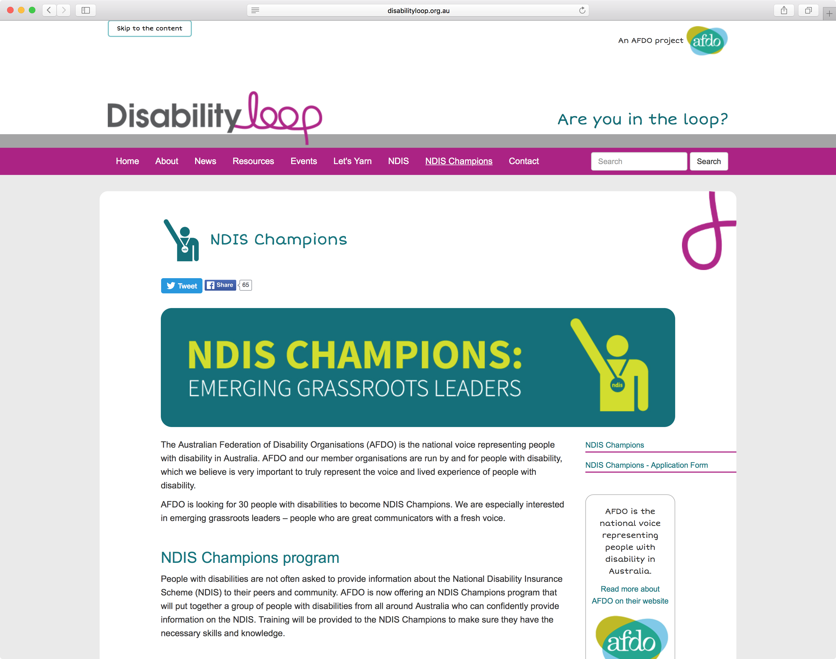

Activity
You have given a presentation to people with disability who are concerned about whether or not it is still OK to complain. In question time, a member of the audience asks where they can find some further information about how decisions that the NDIS makes can be reviewed.
Questions
How would you suggest they go about finding this information? Which website?
Which pages would you suggest they go to?
How would you suggest that they stay informed?

What other NDIS resources are you aware of that you think are really good?

